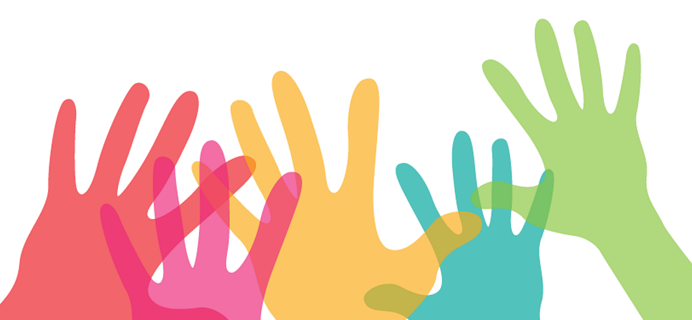
Third Ward Health Collaborative Overview
Vision: Residents, health-focused associations, and community stakeholder organizations are partnered and invested in impactful community-approved projects, working together to care for, support, and uplift one another.
Purpose: Support and facilitate the improvement of health outcomes in the 3rd Ward community
The Third Ward Health Collaborative is a project-driven collaborative of solution-oriented residents and stakeholders who are empowered to take action toward building and supporting a healthier Third Ward community. The Collaborative is founded on the belief that the Third Ward community possesses the capacity, resources, and alliances it needs to transform the health of our community. The collaborative will provide a dynamic and engaging space where talents, knowledge, and interests converge resulting in innovative community-level projects that will support the health of Third Ward residents.
Health Collaborative Priority Areas
- Maternal Health  - Food Systems  - Service Providers  - Mental Health | - Green Spaces/ Physical Activity  - School-Based Health  - Transportation  - Senior Citizen’s Health

The Third Ward Health Collaborative was formed through the collaboration of two Third Ward community development initiatives, The Northern Third Ward Neighborhood Implementation Project and the Mayor’s Complete Communities – Third Ward. The Collaborative responds directly to health data and findings pulled from a number of sources including but not limited to The Northern Third Ward Neighborhood Plan, The Complete Communities Action Plan, and The Baker Institute-Sankofa Research Institute Comprehensive Needs Assessment.
Momentum for establishing the Third Ward Health Collaborative was established through a number of planning meetings leading up to a Third Ward Health Summit. The Summit provided an opportunity for those wanting to take action in addressing the health challenges of the Northern Third Ward community to connect and assess our collective strengths and define the direction and future programs of the Third Ward Health Collaborative. Summit Goals:
  - Gather data from attendees to compile an inventory of Third Ward health services and programs.
  - Gather a list of upcoming health-related events for the year from participants.
  - Inform participants of the health needs of the Northern Third Ward.
  - Share and brainstorm potential models and ideas to be implemented in the Third Ward community.
  - Kick off the Third Ward Health Collaborative.

TWHC Structure & Roles:
- Advisory Team: Collaborative Leadership; Reviews project proposals and facilitates movement toward the TWHC goals.
- Anchor Organization Representative: Support TWHC as larger community partner/stakeholder group; Attends bi-monthly Advisory Team Meetings
- Project Lead: Manages the execution of the proposed and TWHC approved project. Holds project team accountable to goals, plans, and tasks
- Project Key Person: A TWHC member and project support team person actively contributing and working toward project completion
- Collaborative Member: Participates in Health Collaborative general meetings. Contributes in voting for or against proposed projects; Advocates for Third Ward community members; Assists in connecting resources to TWHC projects.

I understand the vision, goals, and priorities of the Third Ward Health Collaborative. I would like to join TWHC as a
___ Collaborative Member
___ Advisory Team Member
___ Anchor Organization Representative

Signature of Collaborative Member:

(print) _______________________________________

(sign) ________________________________________ Date: __________________

- Who are you representing within the Collaborative? (Check all that apply):
Individual (yourself) □ Are you a Third Ward resident? Yes □ No□
Associations □ Name of association: _______________________________________________
Organization/institution □ Name of org/institution: ____________________________________________
- Personal Information:
Name: _____________________________________________________________________________________
Email: _____________________________________________________________________________________
Phone Number: _____________________________________________________________________________
- What assets could you bring to the Third Ward Health Collaborative? (Check as many as possible, expound):
Building/Facility Space □, Political Connections □, Community/ Resident Network □, Financial Capital □, Knowledge of History and Culture □, Social Networking Skills □, Marketing□ , Community Cultural Organizations □, Computer Skills □, Counseling/ Therapy □, Event Planning □, Access to public forums (media/clergy) □, Time □, Art/ Artist □ , Logistics Expertise □ , Youth Connections □ , Grant Writing □, Health Programs □, Health Profession Expertise □, Other □,
Please Expound: ______________________________________________________________________________ ____________________________________________________________________________________________________________________________________________________________________________________________________________________________________________________________________________________________________________________________________________________________________________

- How are you connected to the Third Ward and its community: (how can you participate)

- Complete the following statements:
In my community, I am passionate about:
I am gifted in:
I am able to teach others in my community about:
I wish to learn from others in my community in the following areas:

- Rank each from 1 (lowest) to 5 (highest) the role/capacity in which you see yourself interacting with the Third Ward Health Collaborative.
____ Action Taker (rank from 1-lowest to 5-highest)

____ Brainstormer (rank from 1-lowest to 5-highest)

____ Connector (rank from 1-lowest to 5-highest)

____ Funder (rank from 1-lowest to 5-highest)

- Please list notable events and dates for the upcoming year you want to share:
Event(s): ___________________________________________________________________________________
Date(s): ____________________________________________________________________________________
Location(s): _________________________________________________________________________________
Contact Information(s):________________________________________________________________________
Event(s): ___________________________________________________________________________________
Date(s): ____________________________________________________________________________________
Location(s): _________________________________________________________________________________
Contact Information(s):________________________________________________________________________
Event(s): ___________________________________________________________________________________
Date(s): ____________________________________________________________________________________
Location(s): _________________________________________________________________________________
Contact Information(s):________________________________________________________________________
Event(s): ___________________________________________________________________________________
Date(s): ____________________________________________________________________________________
Location(s): _________________________________________________________________________________
Contact Information(s):________________________________________________________________________
Event(s): ___________________________________________________________________________________
Date(s): ____________________________________________________________________________________
Location(s): _________________________________________________________________________________
Contact Information(s):________________________________________________________________________

